New-In The Storm Dramatic Ending
3.4.22
Prophetic Song about the Sequence of Events in the Rapture

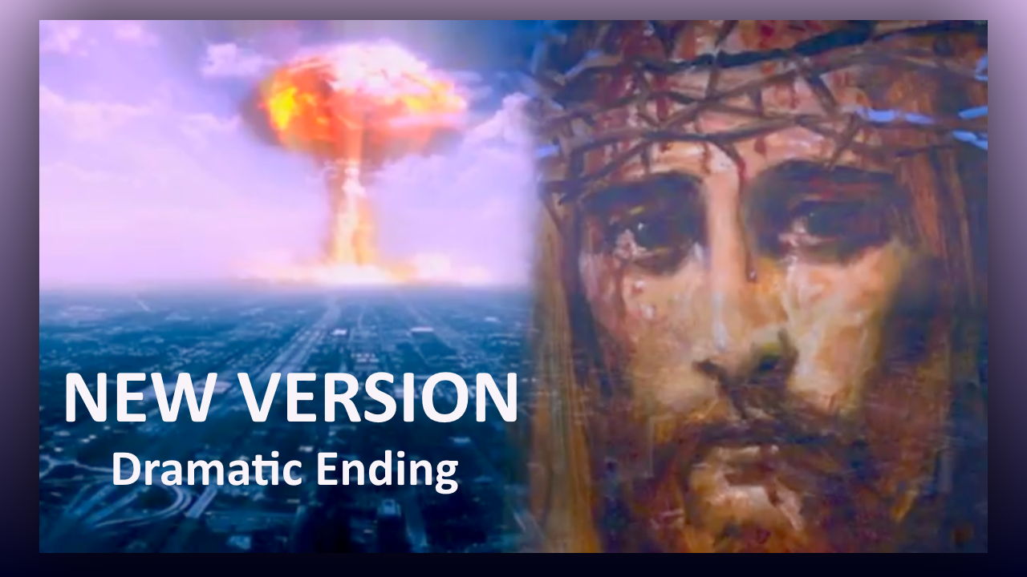

When the mountains shake the seas, then You’ll come to rescue me,
for Your love will not be shaken in the storm.
When we’re shattered to the core, in the dreaded crypt of war,
the hearts of men will fail them in the storm.
With the piercing trumpet’s cry, lightning rips through crimson skies,
and all who have been waiting will arise.
Vindication fills the skies, clouds of saints ascend on high,
as the King in all His grandeur takes His Bride.

In the tattered robes of war, those left standing at the Door
will weep in Outer Darkness…in the Storm.
Now this absence of the Light, it will set the lost aright
as they cry aloud for answers…in the Storm.
So, despite the bolted Door, be repentant and implore,
for His Mercy will restore you in the Storm.

So, trim your lamp, tend to your light. It’s not too late to get it right,
He’s standing here beside you, take His hand.
For He’s coming at an hour…you know not when.

I tried, I tried. We tried to tell you. We tried to no avail.
To no avail...

